Armagan O, Bakilan F, Ozgen M, and et al. Effects of placebo-controlled continuous and pulsed ultrasound treatments on carpal tunnel syndrome: a randomized trial. Clinics. 2014; 69(8):524-528.
PMID: 25141110

Critique author: Linda Metzger
Date: 1-8-15
Design: Randomized controlled trial

Objective: To compare the effectiveness of pulsed and continuous ultrasound (US) treatments combined with splint therapy to a placebo in reducing pain and improving functionality in patients with mild and moderate idiopathic carpal tunnel syndrome (CTS).

Population /sample size/setting:

- A total of 46 female patients (mean age 44 years) with clinical and electrophysiological evidence of mild or moderate idiopathic CTS were recruited in the outpatient clinic of the Eskisehir Osmangazi University Faculty of Medicine, Department of Physical Medicine and Rehabilitation in Eskisehir, Turkey between October 2011 and January 2013. All of the patients had unilateral CTS and were right-handed.
- The 46 patients were randomly assigned to one of the 3 groups: group 1 (n = 15) received splinting and continuous US therapy; group 2 (n = 16) received splinting and pulsed US therapy and group 3 (n = 15) received splinting and a ‘sham’ (placebo) US therapy.
- Inclusion criteria included mild or moderate idiopathic carpal tunnel syndrome without thenar atrophy or spontaneous activity on electrophysiological examination of the abductor pollicis brevis (APB) muscle.
- Exclusion criteria included secondary entrapment neuropathies, cervical radiculopathy,
systemic diseases with increased risk of carpal tunnel syndrome, previous surgical relief, previous treatment with ultrasound, a history of steroid injections into the carpal tunnel, physical therapy within the last 3 months, and patients with either thenar atrophy or spontaneous activity (fibrillation potentials and positive sharp waves) on electrophysiological examination.

Methods/Interventions/Outcome Measures:

- Study design was a prospective, randomized, placebo-controlled, double-blind study. All of the patients were assessed by the same blinded physiatrist before beginning treatment and at the end of the three weeks of treatment. Neither the investigator nor the patients were informed of the treatment assignments.
- Patients included in the study were randomly assigned to one of three groups using a secure system of opaque closed envelopes that were numbered from 1 to 3.
- All patients in the 3 groups were given custom-made neutral volar splints to be worn at night and during the day during the 3-week treatment. Continuous, pulsed and sham US therapies were performed on all of the patients by the same physiotherapist. The first group also received continuous ultrasound at an intensity of 1.0 W/cm² and set at a frequency of 1 MHz administered to the carpal tunnel area for 10 minutes with a transducer of 5 cm² in size using aquasonic gel. The second group received pulsed ultrasound treatment at the same frequency and intensity at a pulsed mode duty cycle of 1:4. Group 3 (placebo) received a sham ultrasound treatment using the same US device which appeared to be working but did not deliver any output. All treatments were given 5 days a week for 3 weeks for a total of 15 sessions.
- Outcome measures were assessed at baseline (pre-treatment) and post-treatment. The primary outcome measure was change from baseline in symptom severity using the self-assessment Boston questionnaire (BCTQ) Symptom Severity Scale. Secondary outcome measures included change from baseline in pain severity using the Visual Analogue Scale scores, change in functional status using the Functional Status Scale scores of the BCTQ, and changes in the median nerve motor conduction velocity, and distal latency and sensory conduction velocity of the median nerve in the 2nd finger and palm using an electromyography apparatus for these electrodiagnostic tests.
- Sample size power calculations were evaluated using a one-way ANOVA and the power of the study was set at 0.70 (70%) with a significance level set at p < 0.05.
Results:
- No significant differences were observed between the groups for the demographic characteristics of age and duration of symptoms. Average age among the 3 groups was 44.3 years and average duration of symptoms was 12.5 months.
- Baseline outcome measurements before any treatments on the BCTQ for symptom severity, VAS scores, and all the electrophysiological parameters were not significantly different between the 3 groups. However, baseline functional scores on the BCTQ were significantly different between the 3 groups (p=0.019).
- There were statistically significant improvements within all 3 groups for symptom severity, functional status, and pain severity from baseline to the end of treatment at 3 weeks. The 6 electrophysiological parameters did not consistently show statistically significant improvements from baseline to the end of treatment at 3 weeks.
- There were no significant differences between the groups for any of the outcome measurements at the end of the 3 week treatment.

Authors’ conclusions:

- Splinting therapy in combination with pulsed, continuous, or placebo US showed similar clinical results. Patients who were treated with continuous and pulsed US showed electrophysiological improvement, but the results that were obtained were not superior to those that were reported with the placebo.
- We believe that this electrophysiological improvement is related to the mechanism of action of US therapy.
- There is no consensus in the literature regarding the optimally effective therapeutic dose (intensity, frequency of sound waves, duration, pulse) for US therapy.
- The lack of intergroup differences in the electrophysiological parameters may be related to the small sample size.
- The main limitations of this study were the relatively small number of patients and lack of data describing a long-term follow-up of the patients.
- Well-designed studies with long-term follow-up are needed to determine the optimal therapeutic US parameters.

Comments:

- This study supports the conclusion that pulsed and continuous US are no more effective than placebo US in the conservative treatment of patients affected by CTS. No statistically significant differences between the 3 groups were observed for any of the outcome measures at the end of the 3 week treatment, including the electrophysiological parameters.
- All 3 groups improved after 3 weeks of treatment. The significant reduction in subjective pain perception and symptom severity, and an increased function assessed by the BCTQ at the end of the treatment in all 3 groups may be attributable to wearing the hand splints for 3 weeks, since all 3 groups received this intervention.
- Strengths of this study included outcomes assessor and patient blinding, the inclusion of a placebo control group, independent observations, and primary outcome clearly designated.
- Limited data on demographic characteristics were given (just age and duration of symptoms) and so it is unknown if the groups differed significantly in other demographic characteristics. It would have been useful to have demographic information on personal characteristics such as smoking, employment, educational level, household income, and other ergonomic factors.
- Since baseline functional scores on the BCTQ were significantly different between the 3 groups, it reduces our confidence in the outcome measurements or results for this parameter. This baseline imbalance may influence outcome, since now differences in outcome cannot be assumed to be due only to the treatment intervention. This imbalance can also bias statistical tests, and introduce chance bias. An analysis of co-variance should have been performed using the baseline score as a co-variant to correct for this imbalance. It is possible, but not likely, that the pulsed US group may have shown a small functional advantage. Since the results for functional status showed no differences between groups after treatment, this imbalance may have exerted only minimal influence on the outcome.
- There were statistically significant improvements within all 3 groups for symptom severity, functional status, and pain severity (VAS) from baseline to the end of treatment at 3 weeks. In the pulsed and placebo US groups, the VAS scores also showed clinically significant improvements (a reduction of 2.9 and 1.7 points, respectively, on a 10 point VAS scale), but the continuous US group did not show a clinically significant decrease in pain (a reduction of 1.0 points). It is unclear if the symptom severity scores and the functional status scores showed clinically significant within group improvements, since it is unclear what scoring scale was used. The BCTQ instrument normally uses an ordinal scale that generates a final score that ranges between 1 to 5 points. The scores presented in Table 2 shows functional and severity scores that range from 14 to 29 points. The Table scores may be off by one decimal place, or they may be the sum of all the individual scores instead of the final score which is divided by the number of items in the scale. It is unknown and greatly hinders the interpretability of the results. However, if one analyzes the percent change from baseline to post-treatment, only the scores for the pulsed and placebo US groups show clinical significance. The continuous US group does not show clinically significant improvements in function or severity symptoms.
- The study failed to report on compliance with wearing the hand splint among the 3 groups. It is therefore not known if one group wore the splint more than another group which could affect the outcome.
- Sample size calculations were not presented. The sample sizes for each group were too small (15, 16, 15), and the study lacked adequate power (set at 70%) to detect significant differences in all the outcome measures. It is desirable for the power to be set at 80% or above. The methodological quality of the study was adequate, but the results are inconclusive because the study is underpowered.
- Since the providers that administered the US treatments to the participants could not be blinded to group allocation, this could introduce performance bias.
- The article text and the abstract are in conflict, designating each intervention to different group numbers.
- Another similar study (Yildiz 2011) on pulsed ultrasound (US) for the treatment of carpal tunnel syndrome was statistically pooled with this small study using Cochrane software (forest plots below) for 3 outcome measures; Boston Symptom Severity Scale, Boston Functional Status Scale and VAS pain. Both studies included pulsed ultrasound plus splinting in the intervention group and used sham ultrasound plus splinting in the control group. The pooled effect sizes for US versus sham US were 0.24 for Symptoms and 0.21 for Function in favor of sham US, and -0.60 for VAS pain in favor of US for the 2 studies. None of these 3 pooled effect sizes were statistically significant. The pooled effect sizes for both Boston scales are smaller than the clinically important differences of 1.0 point and the pooled effect size for VAS pain is smaller than the clinically important difference of 1.5 points. The pooled effect sizes appear to be small, resulting in a therapeutic effect that is clinically unimportant. The confidence intervals do include some clinically significant effect sizes and thus do not exclude a clinically important difference between US and sham US. Overall, the pooled data from the 2 studies shows no statistically significant difference between the 2 interventions of US and sham US, and also does not demonstrate a significant clinical improvement for US.

Forest plot showing pooled effect of ultrasound with splinting vs sham ultrasound with splinting for the Boston Symptom Severity Scale.

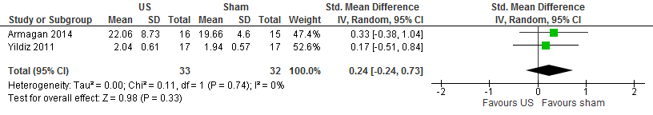
Forest plot showing pooled effect of ultrasound with splinting vs sham ultrasound with splinting for the Boston Functional Status Scale. 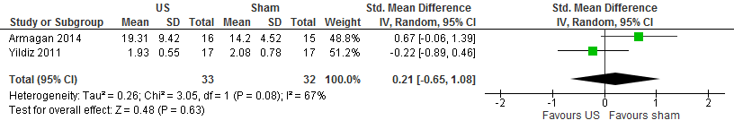

Forest plot showing pooled effect of ultrasound with splinting vs sham ultrasound with splinting for VAS pain scores.
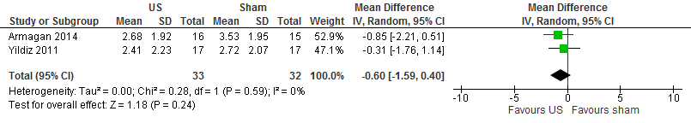

Assessment:

This methodologically adequate study shows that there is an absence of evidence for the effectiveness of pulsed or continuous ultrasound (US) combined with splint therapy compared to sham ultrasound and splint therapy in reducing pain and symptoms and improving functionality for treating patients with mild or moderate idiopathic carpal tunnel syndrome (CTS). This study is inconclusive in its ability to find an effect due to only 70% power and a small sample size.

