Yildiz N, Atalaya NS, Gungen GO, and et al. Comparison of ultrasound and ketoprofen phonophoresis in the treatment of carpal tunnel syndrome. Journal of Back and Musculoskeletal Rehabilitation 2011; 24:39–47.
PMID: 21248399

Critique author: Linda Metzger
Date: 2-4-16
Design: Randomized, prospective, controlled, double-blinded clinical trial

Objective: To compare the effectiveness of ultrasound (US) and ketoprofen phonophoresis (PH) in treating patients with carpal tunnel syndrome (CTS).

Population /sample size/setting:

- A total of 51 patients (76 median nerves) including 43 females and 8 males ages 29 to 66 (mean age 48.7 years) with clinical and electrophysiological evidence of mild or moderate CTS were recruited at the Department of Physical Therapy and Rehabilitation in a university medical school in Turkey. All unilateral and bilateral hands with CTS were included in the study.
- The 51 patients were randomly assigned to one of the 3 treatment groups: Group 1 sham US plus splinting (n = 17, 25 median nerves), Group 2 pulsed US plus splinting (n=17, 26 median nerves), and Group 3 ketoprofen phonophoresis with pulsed US plus splinting (n=17, 26 median nerves).
- Inclusion criteria included symptom duration and signs of suspected CTS of at least one month and electrophysiologic evidence of mild or moderate CTS.
- Exclusion criteria included corticosteroid injection before the study, physical therapy in the previous 3 months, muscle atrophy due to CTS, evidence of obvious underlying causes of CTS such as hypothyroidism, diabetes mellitus, inflammatory rheumatic diseases, arthritis of wrist, acute trauma, or pregnancy, medical problems that would have been contraindicated for US, clinical or electrophysiologic evidence of accompanying conditions that could mimic CTS or interfere with its evaluation such as cervical radiculopathy, or significant polyneuropathy, presence of either fibrillation potentials or reinnervation on needle electromyography in the abductor pollicis brevis muscle.

Methods/Interventions/Outcome Measures:

- Study design was a prospective, randomized, placebo-controlled, double-blind study with 8 weeks of follow-up.
- Motor and sensory nerve conduction studies were performed by a physician in median and ulnar nerves by using standard techniques in all patients. Clinical exams were performed by a physiatrist who was blinded to the groups at the initial visit.
- The randomization list was produced with a random number generator. After the eligible patients had been enrolled, a non-blinded physiatrist who was not involved in the treatment allocated the involved wrist of each consecutive patient to PH, US or sham treatment group by means of sequentially numbered sealed envelopes containing the group allocation (sham, US or PH). This physiatrist was the only person aware of treatment allocation during the trial.
- All of the patients wore a neutral, custom molded thermoplastic volar wrist splint at night and during the day for 8 weeks. Patients checked the days they used the splint on a form for monitoring compliance. Patients were considered non-compliant with splinting if they did not wear the splint more than once a week.
- In Group 1, patients received sham US with an acoustic gel without any medication via a Chattonooga Group, Model 27335 ultrasound system in the off mode. In Group 2, patients received pulsed mode (1:4) US with an acoustic gel without any medication at 1 MHz frequency and 1W/cm² intensity. In Group 3, patients received pulsed mode (1:4) US with 2.5% ketoprofen gel at 1 MHz frequency and 1W/cm² intensity.
- All US treatments were made with a transducer to the skin area over the carpal tunnel with 15 minute sessions, once a day, 5 times a week, for 2 weeks (10 total treatments) by a blinded physiatrist unaware of treatment allocation. Another unblinded physician who was aware of treatment allocations switched the US machine on or off before each treatment session. Both ketoprofen and acoustic gel tubes were covered to hide their identities. All physicians who delivered treatments were unaware of the treatment allocation.
- Baseline and post-treatment (2nd and 8th week) evaluations, both clinical and electrophysiological, were performed by blinded physicians.
- The patients were not informed of their treatment assignments. Patients were not allowed to use any medications or physical therapy throughout the study.
- Outcome measures included 2 electrophysiologic parameters; median motor distal latency (mMDL) and median sensory distal latency (mSDL). There were 3 clinical parameters; functional status scale (FSS), symptom severity scale (SSS) and visual analog scale (VAS). FSS and SSS were evaluated using the self-assessment Boston questionnaire.
- Two analyses were conducted. The intention to treat (ITT) analysis included all randomized patients who received treatment at least once. The per protocol (PP) analysis included only those patients who complied with the study protocol.
- The significance level of the study was set at p < 0.05.
Results:
- No significant differences were observed between the groups for the demographic characteristics. Average duration of symptoms in the 3 groups was 12 to 13 months.
- All 51 selected participants were included in the ITT analysis. Only 44 patients were included in the PP analysis because 7 patients did not finish the study due to splinting non-compliance, illness, or loss to follow-up.
- Baseline measurements before any treatments for all 5 of the outcome measures were not significantly different between the 3 groups.
- Statistically non-significant improvements were found in all outcome measures (VAS, FSS, SSS, mMDL and mSDL) within all groups at the end of the treatment (2 weeks) and at the 8th week for both the ITT and PP analysis.
- The only statistically significant difference observed between the groups for any outcome measure was for VAS scores at week 8. Only the VAS pain score was significantly lower in Group 3 at the 8th week compared to the other 2 treatment groups. These decreases in the VAS pain scores were clinically significant as well in both the ITT and PP analyses.
- For most outcome measures in groups 1 and 2, the greatest improvements were seen at 2 weeks compared to 8 weeks post-treatment. In group 3, the greatest improvements were seen at 8 weeks compared to 2 weeks.
- There were no statistically significant differences between Group 1 and Group 2 in all outcome measures assessed at both follow- ups.
- No complications or side effects were reported during or after the treatment period for both the US treatments and the ketoprofen phonophoresis.

Authors’ conclusions:

- Improvements in all the clinical and all the electrophysiological outcomes were observed in all treatment groups at the 2nd and 8th week in the study. The results of this study also showed that the combination of US therapy and splinting was not superior to splinting alone. In addition, it was found that ketoprofen PH was more effective in decreasing pain compared to splinting alone and splinting with US therapy at the 8th week.
- This study showed that the addition of US therapy to splinting did not improve the clinical and electrophysiological outcomes in patients with CTS. Therefore, US used in combination with splinting does not seem to be effective.
- The results of this study suggest that ketoprofen PH in addition to splinting was more effective in decreasing pain and is superior to splinting alone and the combination of US and splinting at the 8th week in patients with CTS. There were no other statistically significant differences in any other of the outcome measures between the three groups at the end of the study or at the 8th week.
- There is no consensus regarding the optimally effective therapeutic dose and treatment schedule (amplitude, pulse, duration, etc.) for US therapy.

Comments:

- This study supports the conclusion that US therapy plus splinting is no more effective than splinting alone in the conservative treatment of patients affected by CTS. No statistically significant differences between these 2 groups were observed for any of the clinical and electrophysiological outcome measures at the end of the 2 week treatment or at 8 weeks.
- This study supports the conclusion that ketoprofen PH in addition to splinting was more effective in decreasing pain than splinting alone or the combination of US and splinting at the 8th week after treatment in patients with CTS.
- All 3 groups revealed similar improvements after 2 weeks of treatment. The significant reduction in subjective pain perception and symptom severity, and an increased function at the end of the treatment in all 3 groups may be attributable to a “placebo effect”. A possible explanation for these non-specific treatment effects may be attributed to the attention, interest, and concern displayed by the physician or physiotherapist, or patient expectations of the treatment effects.
- Even though the authors report improvements in all outcome measures in all groups, only the VAS pain scores at the 8th week in Group 3 were statistically significant and clinically important improvements.
- Strengths of this study included outcomes assessor and patient blinding, the inclusion of a splinting control group, monitoring for splinting compliance, a Bonferroni adjustment for multiple comparisons, a mid-term follow-up time, and completion of both ITT and PP analyses.
- The authors failed to perform sample size power calculations for the study. It is unknown if the sample size was adequate to detect significant differences in the outcomes. Since the results did detect a difference in the third group in the VAS scores, it is unlikely that a larger sample size would have helped to detect significant differences in the other outcomes among the 3 groups.
- The primary outcome should have been clearly designated, since 5 separate outcome measures were described. Only one of 5 outcome measures (VAS Score) was statistically significant and showed a positive difference between groups. Basing the conclusions of the study on just the one positive outcome is selective outcome reporting.
- A major limitation of the study was that it violated the assumption of independent observations for the Student T test which was used for data analysis. The observations in this study lack independence from one another, since most (51) of the 76 symptomatic hands analyzed in this study came from patients with bilateral CTS. For observations to be independent, they must come from different individuals. Non-independent observations can make the results of the Student T Test incorrect or misleading, or simply give too many false positives. Thus the conclusions from this study are suspect for violating the assumptions of the statistical test.
- One limitation of the study was the lack of adjustment for any imbalances in the baseline scores in the analysis by not including the baseline scores as covariates in the analysis of variance. This analysis would have increased our confidence in the internal validity of the study.
- Another limitation in the study was the absence of a control group receiving any treatment which would have been useful to detect the effectiveness of splinting alone.
- Another important limitation in this study was the relatively small sample size.
- Only the short to mid-term effectiveness of US and ketoprofen PH was evaluated. Well-designed larger, studies with long-term follow-up are warranted to determine the long-term effectiveness of US and ketoprofen PH.
- Another similar study (Armagan 2014) on pulsed ultrasound (US) for the treatment of carpal tunnel syndrome was statistically pooled with this small study using Cochrane software (forest plots below) for 3 outcome measures; Boston Symptom Severity Scale, Boston Functional Status Scale and VAS pain. Both studies included pulsed ultrasound plus splinting in the intervention group and used sham ultrasound plus splinting in the control group. The pooled effect sizes for US versus sham US were 0.24 for Symptoms and 0.21 for Function in favor of sham US, and -0.60 for VAS pain in favor of US for the 2 studies. None of these 3 pooled effect sizes were statistically significant. The pooled effect sizes for both Boston scales are smaller than the clinically important differences of 1.0 point and the pooled effect size for VAS pain is smaller than the clinically important difference of 1.5 points. The pooled effect sizes appear to be small, resulting in a therapeutic effect that is clinically unimportant. The confidence intervals do include some clinically significant effect sizes and thus do not exclude a clinically important difference between US and sham US. Overall, the pooled data from the 2 studies shows no statistically significant difference between the 2 interventions of US and sham US, and also does not demonstrate a significant clinical improvement for US.

Forest plot showing pooled effect of ultrasound with splinting vs sham ultrasound with splinting for the Boston Symptom Severity Scale.
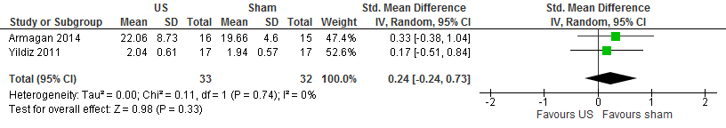

Forest plot showing pooled effect of ultrasound with splinting vs sham ultrasound with splinting for the Boston Functional Status Scale. 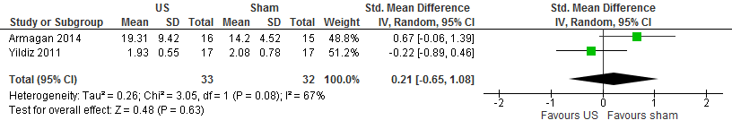

Forest plot showing pooled effect of ultrasound with splinting vs sham ultrasound with splinting for VAS pain scores.
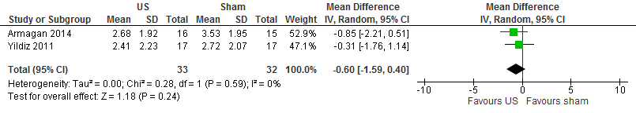

Assessment:

This adequate study provides some evidence that ultrasound (US) therapy plus splinting is no more effective than placebo ultrasound plus splinting in reducing pain and symptoms and improving functionality in the conservative treatment of patients with carpal tunnel syndrome (CTS), and ketoprofen phonophoresis applied with ultrasound plus splinting was more effective in decreasing pain than the combination of US and splinting or splinting alone at the 8th week after treatment in patients with CTS.

